

Recruitment Pack
Repairs Assistant
Closing Date:
Thursday 29th January 2026 at 12 Noon

Contents

Welcome from CEO | 3
About Us | 4
Our Vision & Values | 5
Job Role/Description | 6
Person Specification | 9
Key Relationships | 11
The Selection Process | 11
Summary of Terms | 12
Contact Us | 13

Welcome from the CEO
Dear Applicant,

Thank you for your interest in working with Southside Housing Association as our Repairs Assistant. This pack will provide you with details of the role and information about the Association to assist you in the application process.

If you have any questions, or would like to discuss the role further, please contact Aileen Radford – aradford@southside-ha.co.uk. In addition, our Director of Property Services, Paul McColgan, is available for an informal confidential discussion. Please arrange this via Aileen Radford.

Should this opportunity be of interest to you, please complete the application form and return to recruitment@southside-ha.co.uk.

Thanks again for your interest and I wish you good luck with your application.

Yours faithfully,

Paul McVey
Chief Executive Officer

Our Vision & Values

VISION
We have a vision to support thriving places and communities.
We want:
- All our homes to be popular, affordable, well-maintained & energy efficient;
  - Our customers to receive excellent services from approachable and knowledgeable staff;
  - To service the needs of all communities equally, and;
  - To work with partners to build popular and inclusive neighbourhoods.

VALUES
Professional: We will act with integrity, we will be impartial in the advice we give and the actions we take, and we will be reliable and competent in our work.

Responsive: We will be focused on both the needs of the individual customer and the community.

Progressive: We will seek to empower individuals and communities in our work. We will be proactive in addressing problems and we will tackle inequalities where we find them.
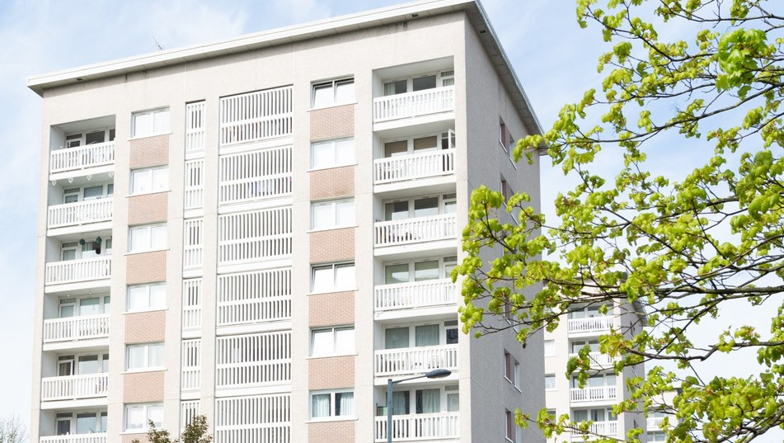

About us

At Southside Housing Association (SHA) we care about our community.

SHA is a registered social landlord providing housing and a range of other services across the south side of Glasgow.

We are community controlled which means our decisions are taken by a tenant-controlled Management Committee. We are also a registered Scottish charity (Scottish Charity Number SC036009).

We have operated as a social landlord on the south side of Glasgow for over forty years and currently own and manage approximately 2,250 houses for social rent, provide a factoring service for a further 1,000 owners and through our subsidiary company, Southside Lettings, have a further 250 properties for Mid-Market Rent. We also have an extensive development programme to build new homes.

Over the years we have expanded the range of services we provide to include:

- A variety of housing options & support Money advice & support
- Community events & activities Repairs & maintenance
- Concierge & common area maintenance

Summary of Terms

Southside Housing Association is a full member of Employers in Voluntary Housing (EVH) and the terms and conditions for this post follow the EVH Terms.
A summary of the principal areas are as follows:

Salary | EVH Grade 7 £39,072 to £42,903
Salary Payment | Salary will be paid on 23rd of each month
Contract Status | Permanent
Hours | 35 hours per week, Monday to Friday. The office is open to the public Monday to Friday, 9am to 5pm.
Place of work | Southside Housing Association, Southside House, 135 Fifty Pitches Road, Glasgow, G51 4EB. The Association has onsite parking.
Holiday Entitlement | 25 days per annum and 15 public holidays per annum
Pension | The Association offers SHAPS Defined Contribution Pension Scheme (Employee contributions 5% and Employer contributions 10%). New staff are auto-enrolled immediately at the above contribution rate
Notice Period | 4 weeks
Professional Fees | One set of professional fees pad per annum
Learning & Development | We are Investors in Young People accredited and we are committed to investing in our people to ensure that staff members within each department are able to contribute fully to the Associations’ objectives.
Additional Benefits | The Association has a culture that promotes work/life balance and is supportive of flexible working requests.  Commitment to continued learning and development.  Staff can access Hospital Saturday Fund (at their own cost).  Access to Cycle to Work Scheme.

Our Vision

We have a vision to support thriving places and communities. We want;

- All our homes to be popular, affordable, well-maintained and energy efficient;
- Our customers to receive excellent services from approachable and knowledgeable staff;
- To serve the needs of all communities equally, and;
- To work with partners to build popular and inclusive neighbourhoods.

To support our vision we are active members of the Scottish Federation of Housing Associations (SFHA), Glasgow and West of Scotland forum of Housing Association (GWSF) and Employers in Voluntary Housing (EVH).

Our Values
- Respect
We will put people first, prioritise relationships, be kind and helpful and treat others as we would want to be treated.

- Integrity
We will conduct ourselves with honesty and transparency

- Positivity
We strive for positive outcomes and focus on the solutions that will deliver them

- Responsibility
We will be dependable, professional, reliable and consistent

Job Role/ Description

Job Details

Job Title | Repairs Assistant | Report to: | Repairs & Voids Manager
Department | Property Services | Date Created | July 2023
Grade | 4 | Last Review Date | December 2025
Points | PA9 to PA12 | Salary | £27,068 - £30,610
Job Summary

The Property Services Section’s main aim is to provide our customers with a high quality and customer focused service that maintains our homes to the standards our customers expect. This includes a range of functions such as reactive, void and planned maintenance work and a factoring service, in addition to providing technical knowledge and support to the Association and its customers. We are a highly motivated team committed to promoting the vision and values of the Association. The core skills of the department are administration, communication, problem solving, team working and project management.

The main focus of the Property Services department is to ensure our assets are maintained and improved, whilst ensuring that our customers are satisfied and we work within our budgets. We are committed to ensuring that the legislative responsibilities and compliance requirements are adhered to and we are responsible to our Board for ensuring we provide regular, accurate and specific reports on our activities. As well as this, we contribute to delivering Association-wide strategies and activities, including the delivery of our wider action programme within the communities we serve.

The focus of the Repairs Assistant post is to provide effective and responsive administration support for the Property Services Department. The role is varied and each Repairs Assistant will have been allocated a role from within the job description, but with an expectation that they can cover all outputs to cover for colleagues. This will be identified with the individual.

The core skills are administration of the data collected and issued, good communication with the Property Services team and the wider Southside HA community and with contractors. Also, communication and liaison with tenants to provide excellent customer service. Communications is through face to face, telephone, email and letter, as well as messaging on 3CX and Teams. You will work effectively on your own, able to prioritise your work to ensure it is handled to create the best outcome. As administrator, you will be required from time to time to take minutes at meetings and to work with the Repairs Coordinator to handle low level complaints

All staff of the Association must understand and implement the values of Southside Housing Association and understand and adhere to the Terms and Conditions of employment and the Association’s Code of Conduct. Adherence to Equality practices and relevant Data Protection and Freedom of Information legislation will be expected.

Values and Competencies

Southside’s Core Values:

- Respect – We will put people first, prioritise relationships, be kind and helpful and treat others as we would want to be treated.

- Integrity – We will conduct ourselves with honesty and transparency.

- Positivity – We strive for positive outcomes and focus on the solutions that will deliver them.

- Responsibility – We will be dependable, professional, reliable and consistent.

Core Competency Areas:

- Communication with staff and external agencies and contractors
- Making things happen within your department
- Show leadership and inspiration at your level in the organisation.

What does this mean for the post holder:
- You will demonstrate an awareness and understanding of your role and your place in the team and take responsibility for your actions.
- You will seek advice and support appropriately from colleagues and line manager.
- You will be self-motivated, positive and supportive of your colleagues and the Board.
- You will demonstrate respect, honesty, and professionalism across all areas of your job.
- You will take responsibility for your development and performance, keeping up to date with new processes and information.
- You will be able to identify training and learning opportunities.

Job Outputs

Role Output |  | Includes the requirement to
Administration of Reactive and Void Repairs is effective, dealt with on time and accurate. |  | - Record reactive repairs as and when they are received from the Property Services Officers and customers.  - Record Void Repairs as instructed by the Property Services Officers.  - Record Reactive Repairs from other sources, to include but not exclusively Estates, CCTV, Complex works, some remedial Contract Service works, Fire Risk Assessments, White goods in Mid-Market Rented Properties.
Administration of job completions |  | - Complete work orders in a timely manner in our Housing Management system when required.
Administration of repair invoices |  | - To follow the routine for monitoring registered invoices and authorise invoices within your delegated authority or ensure the invoice is given to the right person to authorise.
To monitor cyclical works programmes to ensure 100% compliance of completions. These include, but may not be exclusively, Gas, EICR and Gutter Cleaning/Roof inspections. |  | - Keep the database up to date and available for all relevant staff to view;  - Liaise with the contractor to ensure the appointments are issued or if no access, letter again in accordance with our procedure for no access;  - To attend contractor meetings to take minutes and contribute where appropriate.
To assist the Property Services Officers with their administration. |  | - Raise reactive repairs on our Housing Management system.  - Raise void lines where required.  - Contact tenants and owners to arrange inspections and update our Housing Management system.  - Ensure Damp & Mould inspection requests are logged accurately on our database
To provide excellent customer service |  | - Actively listen to tenants, owners and others to fully understand their needs.  - Quickly identify issues and provide effective solutions.  - Be professional at all times, even in challenging situations  - Always maintain a friendly and helpful manner
Keep up to date with training required for the Property Services Section |  | - Attend training, conferences and other events as requested, including technical repairs training, customer service training and corporate HR, Health & Safety and IT training.  - To suggest training to the Repairs Coordinator where you identify skills gaps, throughout the year and at Staff Appraisal.
General Duties |  | - Conduct business in accordance with Southside HA’s Policies and Procedures and in line with legislation.  - Attend and participate in team and other staff meetings.  - Assist with other duties as asked for by the Repairs Coordinator and Repairs & Void Manager.

Person Specification

Requirements | Essential | Desirable | Method of Assessment
Skills & Abilities |  |  | Form | Interview
Educated to higher grade or equivalent | X
Demonstrate excellent IT skills relevant to the post / job description. | X
Present a positive image at all times both internally and externally. | X
Passionate about building customer relationships, champions customer focus and demonstrates great customer service | X
Confident, professional manner with excellent communication skills – both written and verbal | X
Motivated, enthusiastic and self-starting team player with a commitment to represent the department positively and professionally | X
Ability to seek solutions to problems. | X
Experience

Experience of working in a housing or property service environment, with the ability to multi task and ensure excellent communication, organisation and administrative skills are put to good use. |  | X
Experience in a property services environment with the ability to confidently liaise with customers, contractors and internal departments. |  | X
Dealing with and resolving complaints. |  | X
Excellent communication skills using a variety of methods including IT, written and verbal, as well as the ability to effectively plan their workload and be flexible to meet targets and deadlines | X
Comprehensive use of excel and other systems/databases to extract and input content. | X
Values/Attitudes

Committed to Continuous Personal Development, willing to learn and undertake training as required | X
Commitment to continuous improvement and quality in all aspects of work. |  | X
Displays a positive, can-do attitude and is able to work off their own initiative, reacting positively to ever changing expectations and customer needs | X
Flexible and adaptable approach to work, colleagues and customers | X
Knowledge

Demonstrate an understanding of equalities. | X
Fully understands the principles and practice of Data Protection and Freedom of Information. |  | X
Demonstrate an understanding of Asset Management |  | X
Demonstrate an understanding of service delivery in Social Housing ie General Maintenance & Cyclical Maintenance |  | X

Key Relationships

Who? | Why?
Director of Property Services | Head of Department
Repairs & Voids Manager | Manager
Repairs Co-ordinator | Supervisor / Line Manager
Property Services Officers | Colleagues
Repairs Assistants | Team Members
Extended Property Services Team | Assets and Service Contracts
Contractors | Establish a working relationship to ensure quality service delivery and understanding of expectations
Housing Services & Factoring Team | Work together with colleagues in providing an effective voids management service and on aspects of joint service delivery

The Selection Process

Visit our website for more information and to download an application pack via: southside-ha.org/vacancies/

If you need assistance downloading the pack please send an email to recruitment@southside-ha.co.uk and a member of staff will get back to at the earliest opportunity.

Application | Please send your completed application form and criminal convictions form to recruitment@southside-ha.co.uk
Closing Date | Thursday 29th January 2026 at 12 noon.
Interview | Interview invites will be sent by email.
Place of Interview | 135 Fifty Pitches Road, Cardonald, G51 4EB.
Interview Dates | Interviews will take place on Thursday 5th February 2026

Summary of Terms
Southside Housing Association is a full member of Employers in Voluntary Housing (EVH) and the terms and conditions for this post follow the EVH terms. A summary of the principal areas are as follows:

Salary | Employers in Voluntary Housing  Grade 4 - £27,068 - £30,610
Salary Payment | Salary is paid on the 23rd of each month
Contract Status | Permanent
Hours | 17.5 hours per week. The office is open to the public: 9am-5pm Monday to Friday
Place of Work | Southside Housing Association, Southside House, 135 Fifty Pitches Road, Glasgow, G51 4EB. The Association has onsite parking.
Holiday Entitlement | 25 days annual leave and 15 public holidays per annum (pro rata)
Pension | The Association offers SHAPS Defined Contribution pension scheme (Employee contributions 5% and Employer contributions 10%). New staff are auto-enrolled immediately at the above contributions.
GDPR |  | You can view the Association’s Fair Processing Notice on our website –  www.southside-ha.org/data//SHA_Fair_Processing_Notice_



Contact Us

recruitment@southside-ha.co.uk

www.southside-ha.org/working-with-us/

0141 422 1112

135 Fifty Pitches Road, Glasgow G51 4EB

